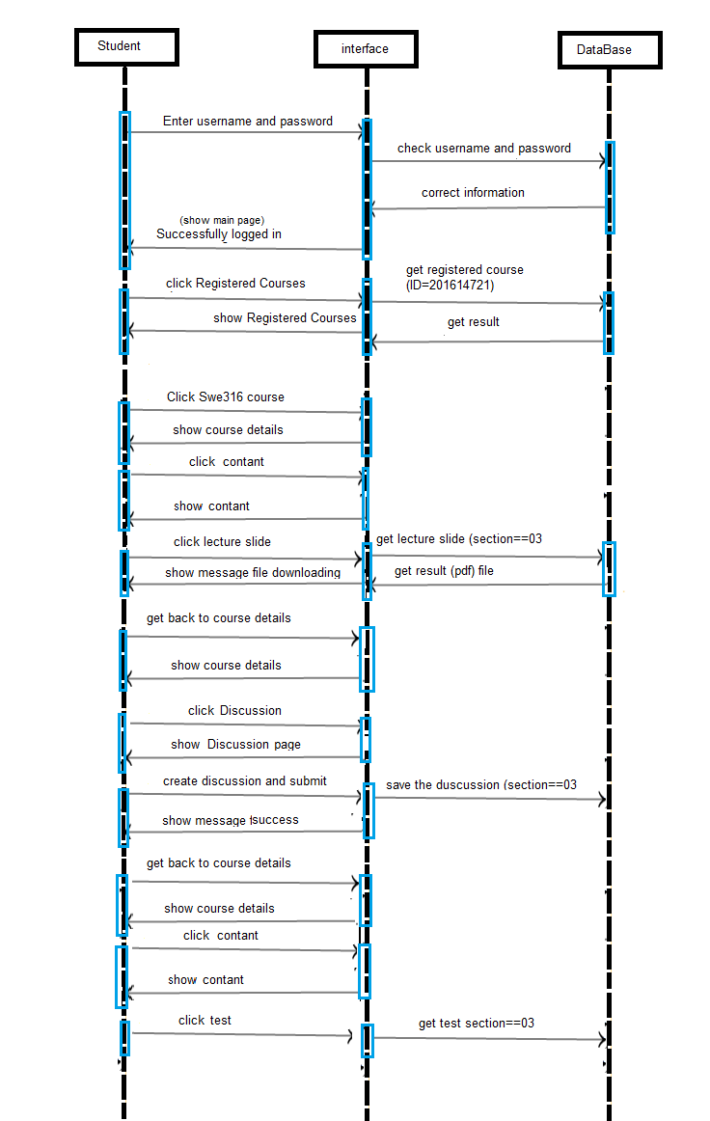Task 1 – UML Use Case Diagram (Total Marks = 05) According to the requirements above, create the UML Sequence Diagram.